**ANPR based Campus Security design document (Requirement & Architecture)**



**Table of Contents**

**Project background** 3

**High Level Requirements** 3

**Functional Requirements** 4

**Functional Scenarios** 6

**User Interface details** 8

**Solution Design** 11

High Level Design: 11

ANPR Component (data flow and integration) 14

HikVision ANPR camera event types 17

**Middleware Structure** 20

**Database Requirements** 21

**Business Component Structure** 23

Business Logic/API Route 23

**Production Requirements** 26

Infrastructure 26

Networking: 26

Salient Features 26

Security 27

Flask Deployment on Nginx with SSL 28

**Additional Data (Annexure)** 36

# **Project background**

* The project will implement Automatic number plate recognition (ANPR) based vehicle detection and management systems across the KIIT campus at different entry and exit points with/ without a boom barrier system.
* This will aid the security personnel and the administration to keep track of the vehicular movement across campuses.
* This system will also help the administration in managing visitors and restriction of unauthorized vehicles inside the campus.
* The solution aims to use cutting edge technology such as IoT and edge AI, secure, and cloud infrastructure to achieve the target.

# **High Level Requirements**

|  |  |
| --- | --- |
| Functional Scope | 1. Track the vehicle based on automatic reading of the Registration number of vehicle plates. 2. Recognize the vehicle by checking in the KIIT Database. 3. Allow only, if the vehicle is registered in KIIT database, else inform the Security Personnel for issuance of temporary permit. 4. Easy e-pass for guests to visit campus. 5. If the vehicle is not registered at KIIT database, Security is allowed to use Mobile App to identify the driver of the vehicle. 6. Track vehicles within campus till exit 7. Safeguard against transfer of temporary permit 8. Identify incidents like crowd, fire etc. |
| Automation Requirements | 1. Camera System – Capture the number plate and validate the vehicle is registered with KIIT. Track the vehicle within the campus till exit. 2. Boom Barrier system – At designated locations the boom barrier can be clubbed with the camera system to make the entry and exit seamless and fully automated. |
| Interface | 1. Security Personnel with Mobile or Tablets running the web application (apps in later phase). 2. Hardware interfaces are ANPR Camera and network interfaces with in Campus network |
| Notifications and Alerts | 1. As standardized notification, channels are Email, SMS. Vehicle exit, when no entry record available. 2. New vehicle at Exit Gate 3. Occurrence of an incidence 4. Visitor without valid epass 5. Registered user with different vehicles. 6. Forced entry/exit. |
| Integration | 1. KIIT has asset master vehicle data in SAP. The proposed solution is expected to get these master asset data from SAP. 2. LDAP for user base and authentication 3. Same time, Digital Solution can also share the asset movement data with SAP – offline. KIIT requires work on the SAP side to load the data from IoT, which is out-of-scope for this engagement. 4. Proposed solution can share and receive data relevant to Campus Security – which is later scope. |
| Personas | 1. CSS Application Admin. 2. KIIT Admin 3. Security Personnel. |
| Reports | 1. Vehicle tracking (Entry/Exit) Report for a period 2. Exception report 3. Incidence report 4. Temporary permit issued report 5. Vehicle not left premises report 6. Full analytics (day wise/ hour wise/month wise /year wise) 7. AI based clustering algorithm to predict and manage crowd during large vents inside university (Later Phase) |

# **Functional Requirements**

|  |  |
| --- | --- |
| Hardware Requirement | 1. ANPR Camera (Hikvision/Honeywell) with power adapter. 2. Network switches 3. NVR /Cloud NVR 4. LAN infrastructure 5. Server (Local/Cloud) 6. Access control gates 7. Communication terminals (PC/Tablet/mobile) |

|  |  |
| --- | --- |
| Client side Requirement | 1. Location for installation 2. Data of all the vehicles owned by the establishment. 3. Data of all the vehicles owned by the employee or associates of the establishment. 4. Data of the type of entry and exit gates with location 5. Security Protocols for visitor management 6. Advertisement about policy to all invited guests and their managing partners. 7. Awareness among security and departments about the protocols. |

Types of Gate Passes (issues depending on the vehicle type as taxi/Registered vehicle/VIP)

* One-time-entry-exit pass is given to vehicles that will enter -exit the premises only one time on the day that the pass was assigned. This kind of pass can be assigned to public vehicles that are entering the premises to pick-up / drop-off people. This can involve vehicles under services such as Uber, Ola etc. and public transports such as autorickshaws. Upon requesting the requester is sent an OTP which they will have to provide at the time of entry for verification. Pass duration – one time / 1 day
* Multi-time-entry-exit passes are assigned to vehicles that need to enter and exit multiple times from the premises for the duration of a day. This can involve people coming via personal vehicles or event vehicles as their routine will be more flexible than people coming via public or rental services. Pass duration – unlimited times / 1 day
* Multi-day-entry-exit passes are assigned to vehicles that need to enter and exit multiple times from the premises for the duration of several days. This can involve people coming via personal vehicles or event vehicles. Pass duration – unlimited times / set number of days
* All-time-entry-exit passes are assigned to vehicles that enter-exit the premises periodically. This type of passes involve staff vehicles and vehicles owned by the organization. Pass
* Special purpose passes are assigned to vehicles such as construction vehicles, these passes limit the vehicles entry by time i.e. the vehicle can enter the premises only within a certain duration and by area i.e. the vehicle can enter only via certain entry points

## **Functional Scenarios**

|  |  |  |
| --- | --- | --- |
| **Scenario** | **Solution/Exception handling** | **Comments** |
| Approaching Vehicle has a pre-approved All-Time-Entry-Exit-Pass and passes through the gate without stopping |  |  |
| Approaching vehicle has a pre-approved Multi-Day-Entry-Exit-Pass and passes through the gate without stopping |  |  |
| Approaching vehicle has a pre-approved Multi-Time-Entry-Exit pass and passes through the gate without stopping |  |  |
| Approaching vehicle has a special purpose and has a limited duration multi-time-entry-exit-pass or a limited duration multi-day entry-exit-pass and passes through the gate without stopping |  |  |
| Approaching vehicle does not have a pre-approved pass and requests the attendant for a one-time entry-exit-pass |  |  |
| Approaching vehicle does not have a pre-approved pass and requests the attendant for a multi-time entry-exit-pass or a multi-day-entry-exit-pass |  |  |
| ANPR camera is down and the attendant has to make manual entry for an approaching vehicle with a pre-approved entry pass of any type |  |  |
| ANPR camera is down and the attendant has to make manual entry for an approaching vehicle without a pre-approved entry pass of any type as well as process the pass request of the vehicle |  |  |
| An individual having an All-Time-Entry-Exit-Pass owns approaching vehicle but the vehicle is not registered to them. The vehicle is stopped and the attendant / security guard has to manually register the vehicle. |  |  |
| For a motorcade to enter, all the vehicles making the motorcade must be pre-approved for passage and can have any type of pass. All the vehicles in the motorcade are assigned a group ID. During entry/exit the number of vehicles passing will be counted. |  |  |

# **User Interface details**

|  |  |
| --- | --- |
| **Software Requirement**  **(Web App/ Mobile App)** | 1. Landing Page 2. Security Login 3. Admin Login 4. Live view 5. Analytics 6. Alerts |

|  |  |
| --- | --- |
| Number of Pages | 10 |

|  |  |  |  |
| --- | --- | --- | --- |
| **Page no.** | **Name** | **Components** | **Functionality (Detailed)** |
| 1 | Landing Page  *Total no pages -6* |  | * **About Us:** This page will provide a brief overview about the company, objectives, projects and scope of work for the clients. * **Support:** This page will have a dynamic form to raise support requests from the client side without logging in. * **Schedule a visit:** This page will have a form field to apply or schedule a visit to the establishment other than employee or associates and issue of E-pass (Addition in the approved table) upon approval from admin. * **Login:** This page will have two options 1 for login as a security personnel or login as administrator. * **Register your vehicle:** Will be used by the transport department or the employee to register vehicle(s) in case of new addition or change in vehicles. This will only be restricted to the establishment employee with valid employee id /id no. |
| 2 | Login Page (Security)  *Total no pages -1* | * Live View * Detected Number Plates * Pass Buttons * Boom Barrier Control. | * **~~Live View :~~** ~~This Place will have live feed from the ANPR camera specific to the gate or campus.~~ * **Number Plate:**  This will provide the detected number plate both in image and in OCR (Text) format. * **Pass Button:**  There will be three buttons   + Guest: For on spot registration for guests who have not registered prior for e-Pass. The data will be stored in the guest of the day column of the dB. Once registered the boom barrier will open or security will allow him/her to enter.   + Taxi: Temporary registration with time limit and alert to all security posts through walkie-talkie or other media about the same. The data will be stored in the Taxi column of the dB.   + KIIT Vehicle: Any new KIIT vehicle will be allowed with production of valid ID card and with an advice to register the vehicle prior next visit. (*Responsibility of the transport department if its KIIT owned or associated else self-registration if employee*) * **Boom Barrier Button:** Will be used for VIPs and dignitaries visiting the campus where there cannot be any delay. In that case, this button will be used to lift the barrier or only capture the number plate data to store in the log table. |
| 3 | Login Page (Admin)  *Total no pages -3* | * ~~Live View~~ * Full Analytics (Separate Page) | This page will have functionality such as the analytic dashboard, full live view which contains   * ~~Live view from all gates of all campuses~~ * Campus specific analytic dashboard which contains number of alerts, guest entry, number e-Passes issued for the day, historical data and filtering of data based on campus, gate, date , time and many more. |

UI structure

* CSS – global
* CSS – Page specific
* HTML pages for forms/view pages
* JQuery

# **Solution Design**

ANPR Solution

~~Boom barrier Based~~

Manual Operation

~~Automatic opening of the boom barrier for the vehicle based on the following criteria~~

~~Registered Vehicle in database.~~

~~Vehicle owned by KIIT and pre registered in db.~~

~~Visitor with a valid E-Pass.~~

~~Guest Pass issued by security~~

Allowance the entry of the vehicle by the security personnel with terminals (mobile/tablet/pc) at gate based on the following criteria after validating the data in the terminal

* Registered Vehicle in database.
* Vehicle owned by KIIT and pre-registered in db.
* Visitor with a valid E-Pass.
* Guest Pass issued by security

### High Level Design:

The solution is proposed to be developed as a three tier application with UI to be exposed as PWA application to be deployed on tablets for the security at the gate.

The backend database is proposed to be Microsoft sql server and middleware application to be developed in Python/Nodejs.

Following is the high-level view of the proposed infrastructure setup across three tiers and spanning Soul/KIIT data center to host the application and relevant servers.

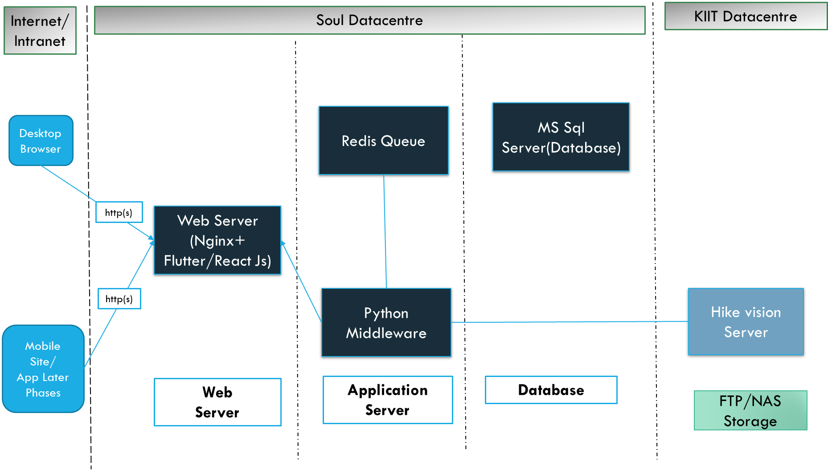

The application will run continuously, listen for vehicle detection event form the camera software, and pass on the vehicle details to the downstream applications.



The data schema for the application can be divided into two parts Master and transactional and analytics or denormalized data for reporting later.

The below suggested schema will be used by the data processing layer to interact with ANPR database.

**Master Data (TBD)**

|  |  |  |  |
| --- | --- | --- | --- |
| Table Name | Constraints/Keys (optional) | Index | Columns and dtypes |
| GateDetails |  |  |  |
| Location |  |  |  |
| Department |  |  |  |
| Employees |  |  |  |
| Alert |  |  |  |
| MeetingPurpose |  |  |  |
| Problem Code |  |  |  |

**Transactional Data (TBD)**

|  |  |  |  |
| --- | --- | --- | --- |
| Table Name | Constraints/Keys (optional) | Index | Column and dtypes |
| Movement Details |  |  |  |
| Regular Pass |  |  |  |
| GuestPass |  |  |  |
| Owner Details |  |  |  |
| Guest Entry |  |  |  |

## ANPR Component (data flow and integration)

Database Objects

To facilitate MIS reporting sql server stored procedures will be used to provide necessary aggregated data. SQL server views will be used to provide the custom dataset used to build reports.

Data Flow: (From Camera - > Gateway - > Server -> Application)

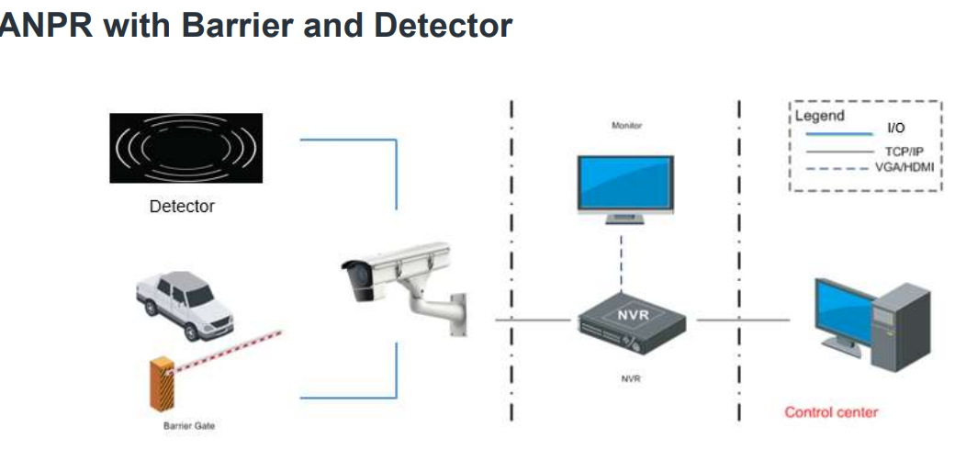

Workflow:

1. The detector sends a signal to the ANPR camera when it detects a vehicle.
2. The ANPR camera recognizes the license plate and opens the gate if it's on the white list.

**ANPR with manual Control and communication**

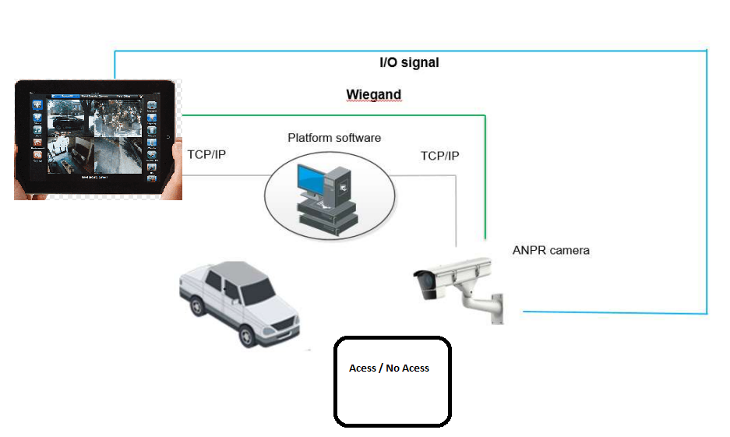

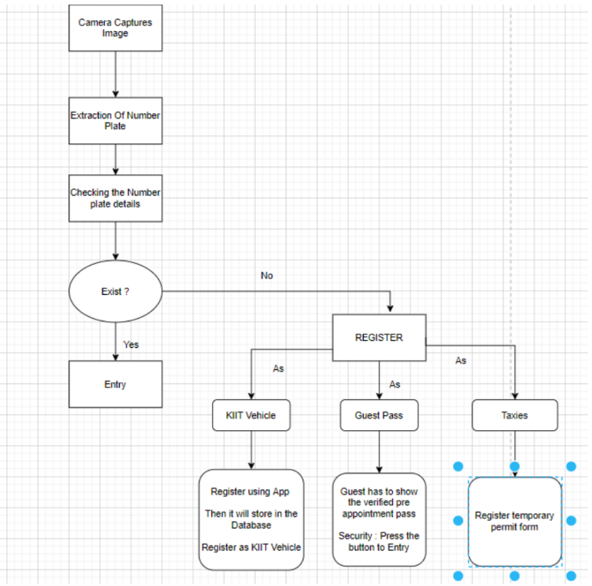

## 

#### HikVision ANPR camera event types

Following are the different even types supported by the Hikvision camera. For the current project, we need to only setup ANPR event type for License plate recognition.

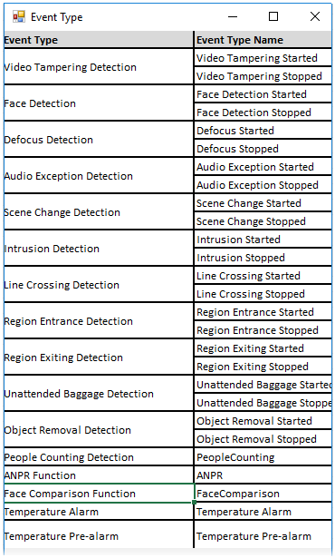

Program Sequence 1 Setup ANPR

The below process flow provides an overview of the setup of the camera thru the provided API/sdk for different programming language or thru the control panel portal supplied by Camera OEM.

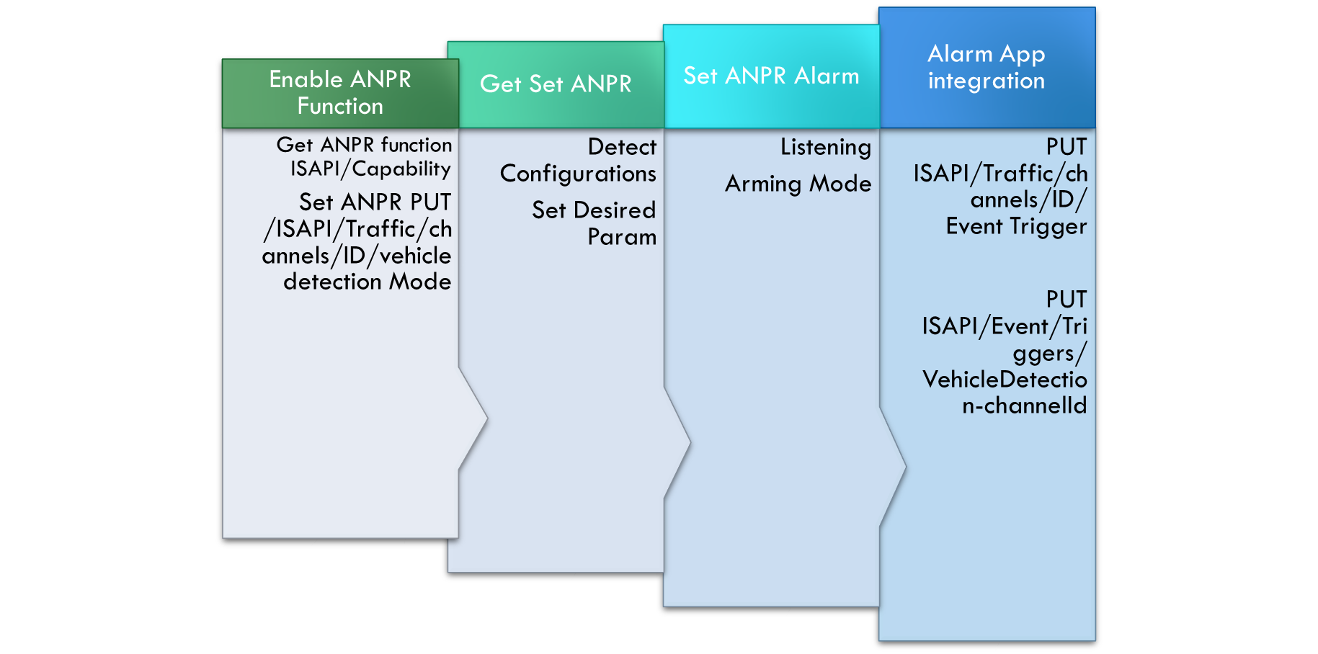

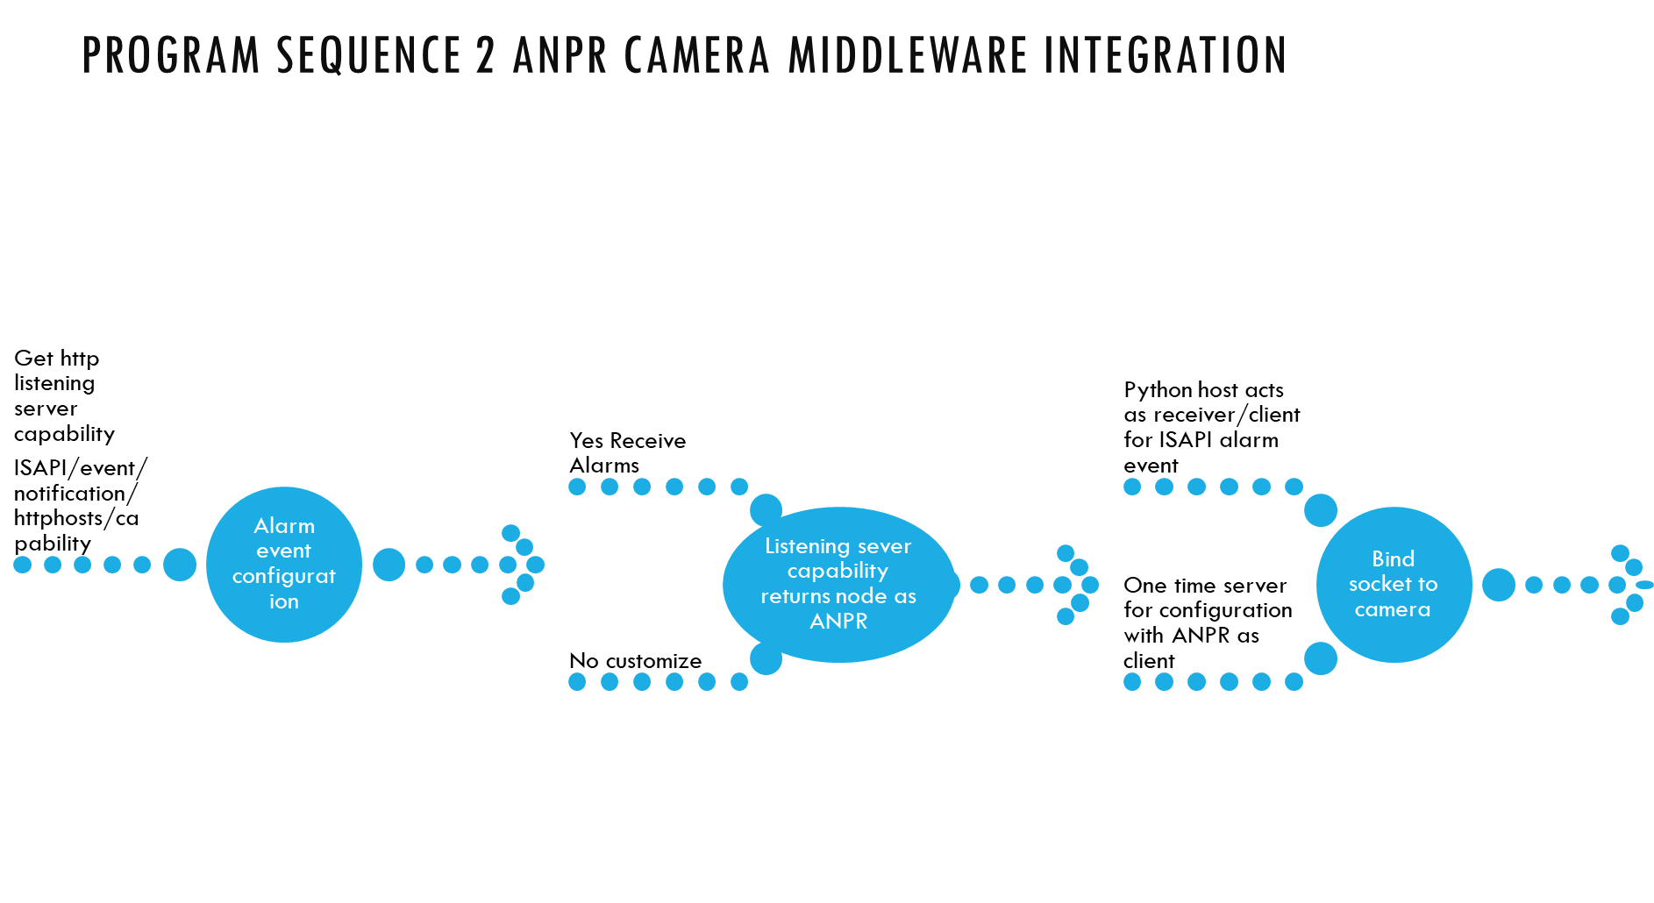

### **Middleware Structure**

***Redis Pub Sub***

Each topic will correspond to a camera or gate and the system will subscribe to topic and get update for each ANPR camera.

Topic

Topic

Topic



*Python – Flutter/PWA API integration*

**MSSQL DB**

**Python Application Server**

**PWA Tab View/Dashboard/Report Page**

AJAX / Get Request

JSON Response + Exception Code

**Python Application Server**

**MSSQL DB**

AJAX POST/PUT Request

**PWA Tab Transaction Form**

Response Status Code/Unique id

## **Database Requirements**

|  |  |
| --- | --- |
| **Database Requirements** | 1. MSSQL Server(Community Edition) |
| **Database Name** | anpr |
| **Tables in dB (Need Revision)** | WIP |
| **index(s)** |  |
| **Constraints(FK)** |  |

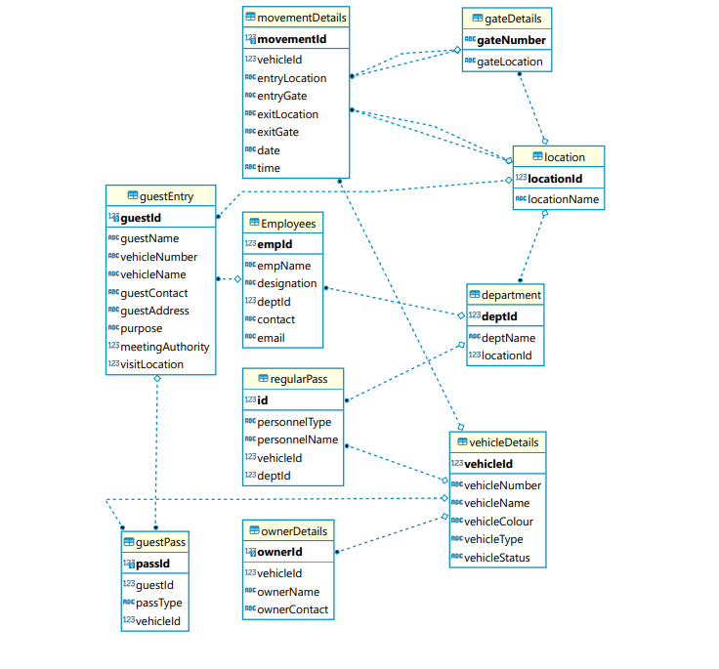

**Backup:**

Daily

**Archival strategy:**

In case database size > archive

**Database Backup/Restore strategy:**

**Security**

Authorization/Role setup

## **Business Component Structure**

Controller Class:  ANPR_Business_component

* Method : RegisterVehicle
* Method : UpdateRegistration
* Method:  IssueGatePass
* Method : Authenticate
* Method : VehicleEntryApproval

Controller Class:  UtilsFunction (Reusable Function)

* Method: ExceptionHandling
* Method: XMLStreamParsing (Input string, input FileData,outputArrayDict)
* Method: JSONPaser (Input string, input FileData,outputArrayDict)

## Business Logic/API Route

Security for APIs:

* **All APIs to follow JWT token based generated tokens and sending the same by client over API call param.**
* **We can use decorators for token or authentication required for API creation and consumption by clients.**
* Access modifiers supported by Python (public methods for all read functions, data retrieval) protected/private method for setting config values/passwords etc.

Web pages/Route

Pages –

1. /Login

Used to authenticate users and show Profile page+menu and dashboard.

This is the init lifecycle of the software to generate sessions and provide profile specific menus as per existing role and permissions.

1. /Admin  (centralized staff)

Data to show in the page

* Counting the total number of vehicles entering the premises
* Counting the total number of unique vehicles entering the premises
* Counting the total number of vehicles scheduled to enter the premises
* Counting the total number of unscheduled vehicles that entered the premises
* Counting the total number of vehicles currently on the premises
* Counting the number of vehicles based on the type of pass issued to them
* Counting the number of vehicles with special purpose passes
* Counting the total number of vehicles that entered the premises for a day

1. /Security (Security Guard Dashboard)

The security staff at the gate can perform following transactions.

* Pass Issue Form
* One-Time-Entry-Exit-Pass Code verification
* Setting

1. /Masters

* Tabular records of all the entries made into and out of the premises
* A record contains plate number of a vehicle, entry and exit date and time, vehicle status based on whether the vehicle is on the premises or not, type of pass issued, pass status.

1. /Visitation_ This page is used by the admin to issue passes from themselves to vehicles and schedule visits to the premises.

* Dignitaries use this in case of visits. The page also controls the list of black listed vehicles

1. /Employee

* Contains name of the employee, employee ID, employee department ,vehicles registered against the employees name, type of pass issued to them, contact number, password.

1. /Profile

Once the user is logged in he can see menus and specific navigation for the currently logged in.

1. /Aboutus

Transactional Data entry Forms –

* Visitor scheduling form
* Login Form
* Contact us form
* Change Profile details form
* Manual Entry Form
* Advanced Search form

# **Production Requirements**

## Infrastructure

OS:

Ubuntu 22 or above with all updated patches for server hosting ANPR application (middleware/application server, web)

$> run ‘Sudo apt update’

$ > run ‘Sudo apt upgrade’

Windows 11 or server for hosting Hikvision Camera setup on IIS server.

Database:

SQL server latest version compatible with Hikvision camera software requirements.

Development Framework/Languages:

Python flask, core python, nodejs, flutter, redis

Tablet

Android latest with device firmware

Load balancing

NA at the moment

## Networking:

* Camera will be connected to KIIT camera network
* ANPR application (middleware and DB) will be installed on a separate network with access to only camera running on port <socket listener>.
* Camera network will only allow https/tcp traffic from ANPR app thru port <camera event alarm notification port>

## Salient Features

* Host multiple applications of the current pilot at multiple applications (load balancer/dedicated servers for middleware/ui/db).
* Support for Tablet as Preferred channel over mobile or desktop

Hosting the web Ui in a progressive web app with support for tablet.

Support for caching of data (optional) like list of registered vehicles and registered campus staff like faculty/KIIT employees etc.

* Operation ability

Warm up script to check connection in specified intervals for the three modules i.e. python on Nginx /redis/db connectivity.

* Monitoring
* Redis queue monitoring: Redis MONITOR tool.

By using the command below command

*Redis-cli monitor*

*qmon*

Redis queue monitoring python based tool qmon.

* Python socket listener: psutil, memory profiler using <https://github.com/getsentry/sentry> for web based python flask monitoring.
* MSSQL DB load monitoring MSSQL client
* Nodejs monitoring

Nodemon, PM2 tool to run nodejs server and collect statistics on screen.

## Security

SSL with domain setup for transport security using TLS /SSL.

## Flask Deployment on Nginx with SSL

We are planning to run the threads in multi process mode.

* One master loader program to run all programs in a sequence or in parallel as per architecture supported by python.
* 1st python socket connector to Hikvision camera
* 2nd  python connection to redis pub sub queue and python to Database server SQL server to read ANPR profile and vehicle data with gate pass information.
* 3rd nodejs to web server/http listener to display web pages .we are planning to use Flutter/React Native as the Progressive web app for tablet Form factor.

We will run all the module or units independently and log exception messages in a file, In case of exception we can optionally send emails to a support email id.

Packaging

Packaging of python modules or dependencies

Requirement.txt to be created which can be installed on target server/VM.

**Flask Application setup on Ngnix with gunicorn app server**

Database

Integrations(Camera)

Redis(optional)

Supervisor

Main module or program of Flask to be app.py or application.py

The module will be invoked by wsgi.py which will be exposed to Nginx or Flask web server

Sudo apt-get install Ngnix supervisor python-pip python-virtualenv

pip3 freeze > requirements.txt (generate requirement or dependency python)

pip install -r requirements.txt (all dependencies listed down)

pip install Flask pip install gunicorn

Run gunicorn in background or as a system service in Linux(to be configured)

gunicorn app:app -b localhost:8000 &

gunicorn --workers <n=no of workers> --bind 0.0.0.0:5000 wsgi:app

Supervisor check process status.

sudo supervisorctl status





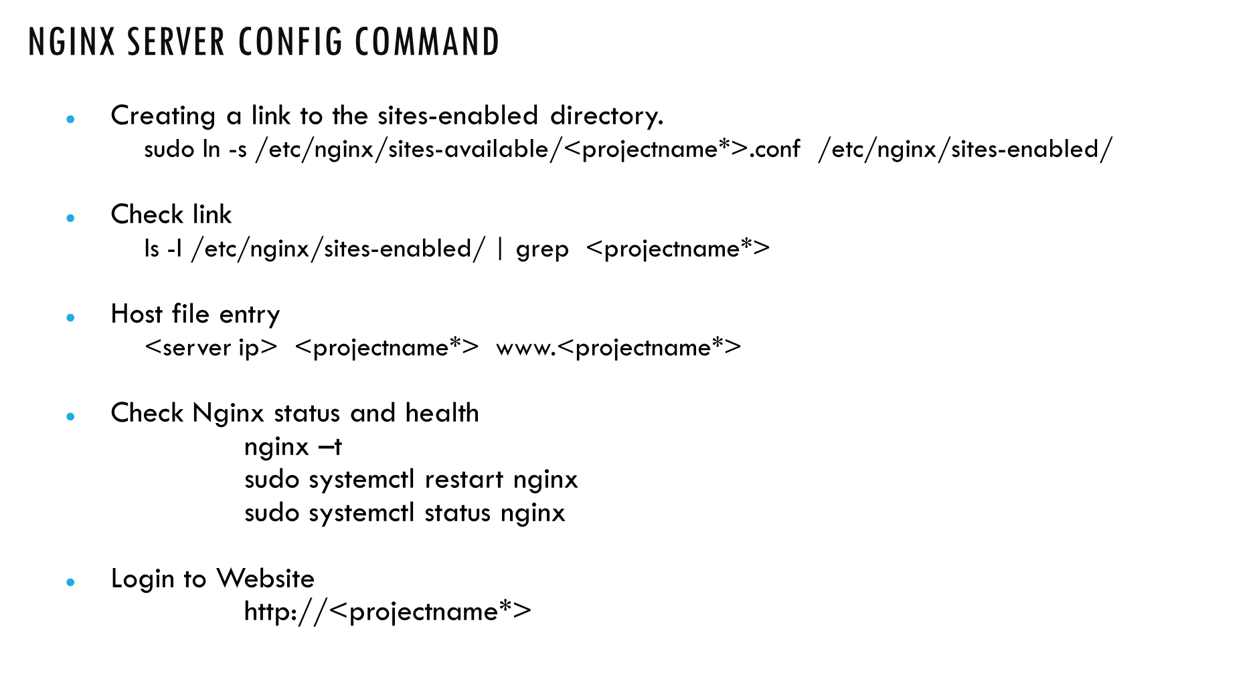



**Exception Handling**

* Server crashed after certain number of transactions
* Server not able to receive any data.
* Hikvision camera is not responsive to ping from Socket listener.
* The plugins have some compilation errors or integration issues.
* The no of messages is high and server is only sending old or cached records.
* Specialized nameplates, which cannot be recognized like Defence/Ambassador corps/dignitaries etc. that may need specialized exception or manual processing.

Testing

* Socket connectivity and connection drops over a period of 1 hour.
* Memory profiling tools (psutil, memory_profiler etc…)
* Web server memory connection and buffer testing

**Python Standard**

**Location:** ~githubURL/Document/

**Controller Class: ANPR_infra (Establish Session with Hikvision)**

* Method: _init
* Method: GetSetCamera

#Login to Hikvision Camera API and get/set session, configuration details

#Validation

Return status code

* Method: GetSetDBConn

#Login to MSSQL server and create a DB connection pool.

#Validation

Return connection instance

* Method: GetSetPuB

#Login to Redis server and create a channel for a camera/topic

#Validation

Return instance

* Method: GetSetSuB(s)

#Login to Redis server and establish connectivity between   subscriber(s) and publishers

#Validation

Return instance

* Method: Socket_Configure

#Create a listener socket and receiver for hikvision camera

#Validation

Return status code

* Method: CameraConfigure

#Create a function to establish session with camera with values read from a DB table/config file like userid/password/url etc..

#Validation

Return status code

**Controller Class:  ANPR_LPR**

Method _init(get connection details)

* Input param : self-instance,tcp_ip,port
* Processing:  listen for vehicle detect events at specified intervals.
* Exception handling : Log exception, Null Data exception,connectionissue exception
* Output :

Method: capture_number_plate

* Input param : self instance,tcp_ip,port
* Processing: Get vehicle data once data is received in the socket and parse the XML file to get Vehicle information.
* Exception handling : Log exception, Null Data exception,connectionissue exception
* Output : collection (Number Plate)

Method: Blacklisting

* Input param : self-instance,data
* Processing : Check vehicle number plate data in case it is blacklisted
* Exception handling : Log exception, Null Data exception,connectionissue exception
* Output : Return Boolean

Method: validate_license_plate

* Input param : self-instance,number_plate
* Processing : Search and return vehicle number as per format below

Odisha : OD xxxx

BH : 022BH….

Replace 0 with “O”

* Exception handling : Log exception, Null Data exception,connectionissue exception
* Output: Return Corrected License plate data.

**Salient features**

* User authentication with ANPR user data exported from KIIT Sap User database.
* API Data interaction : XML/JSON ,Method : Get/POST
* API authentication provides user id password from a secret store instead of hardcoding user/password values in code.
* Generic CSS for all the web pages and any page specific CSS.
* JavaScript common input sanitization functions.
* Logging/Exception handling method.
* Connection pooling for db connection
* Restarting of services.

Security (settings)

* Configuration Data storage
* Encrypting of Data.

# **Additional Data (Annexure)**

**Web Application Components**

|  |  |
| --- | --- |
| **Page-1**  **(LP)** | **About Us (Static Page with fixed Text)** This page will provide a brief overview about the company, objectives, projects and scope of work for the clients. |
| **Page-2**  **(LP)** | **Support:** This page will have a dynamic form to raise support requests from the client side without logging in.  Form Fields will be as follows   |  |  | | --- | --- | | **Establishment Name** | Drop Down to Choose | | **Name** | To be filled by the Requestor | | **Email Address** | To be filled by the Requestor | | **Phone Number/ Cell Number** | To be filled by the Requestor | | **Urgency Level** | Radio Buttons to choose the urgency level | | **Problem Type** | Tick boxes to choose problem type(s) | | **Problem Description** | Describe the Problem in brief. |   Once the form is submitted there will be a pop up with a SR-number and expected resolution time based on the problem type. |
| **Page-3**  **(LP)** | **Schedule a visit:** This page will have a form field to apply or schedule a visit to the establishment other than employees or associates.  Form Fields will be as follows   |  |  | | --- | --- | | **Name of the Visitor** | To be filled by the Requestor | | **Vehicle Number** | To be filled by the Requestor | | **Purpose of Visit** | Can have tick boxes with generic fields | | **Date of Visit** | To be filled by the Requestor (Calendar) | | **Campus /School/Department intended to visit** | To be filled by the Requestor (Can also be given as drop down menu) | | **Duration of Visit** | To be filled by the Requestor | | **Full Address including Country and Post code** | To be filled by the Requestor |   Issue of E-pass (Addition in the approved table) upon approval from admin and triggering of email/sms to the applicant.  Responsibility:   * Admin or Department of KIIT who is inviting the guest. * Self if coming uninvited or official purposes |
| **Page-4**  **(LP)** | **Login:** This page will have two options 1 for login as a security personnel or login as administrator. Standard two button login page.  Example:      The login details will be provided to the designated personnel appointed by the client without any external registration process. |
| **Page-5**  **(LP)** | **Register your vehicle:** Will be used by the transport department or the employee to register vehicle(s) in case of new addition or change in vehicles. This will only be restricted to the establishment employee with valid employee id /id no.  Form Fields will be as follows:   |  |  |  | | --- | --- | --- | |  |  | Data Type | | **Name** | To be filled by the Requestor | String/Text | | **KIIT ID** | ID number (SAP / KIIT Format) | String/Text | | **Upload Snapshot of the ID** | To be uploaded by the Requestor | File | | **Department** | To be filled by the Requestor (Can be given as a drop down menu) | String  Drowdown/multiple values | | **Vehicle Number** | To be filled by the Requestor | String/Text | | **KIIT email id.** | To be filled by the Requestor | String/Text |   Upon addition of a vehicle in the database, the applicant will be notified through his official kiit email id. |
| **Page-6**  **(LP)** | **Contact Us:**  Static page with details of the office location, email address and contact number. |
| **Page-7**  **(LIS)** | **Login Page (Security/Name):**  Upon Login this will open the following interfaces with the functionalities explained in Segment-6 will be populated.  LIVE CAMERA VIEW  Gate Number:  Campus Number:  Captured Image  Detected Number Plate  ALLOWED  NOT ALLOWED  Guest Registration  Taxi Registration  KIIT Vehicle  Boom Barrier  *Logged in as : Name of Security*   |  |  | | --- | --- | | **Button Name** | **Functionality** | | **Guest Registration** | For on spot registration for guests who have not registered prior for e-Pass.  Form field Details:   |  |  | | --- | --- | | **Name of the Visitor** | To be filled | | **Vehicle Number** | Auto Populate from ANPR | | **Purpose of Visit** | Can have tick boxes with generic fields | | **Date of Visit** | Auto Populate | | **Campus /School/Department intended to visit** | To be filled (Can also be given as drop down menu) | | **Full Address including Country and Post code** | To be filled by | | **Duration of Visit** | To be filled by |   The data will be added in the guest of the day table along with the e-Passes. | | **Taxi Registration** | Temporary registration with time limit and alert to all security posts through walkie-talkie or other media about the same.  Form field Details:   |  |  | | --- | --- | | **Name of the Visitor** | To be filled by | | **Vehicle Number** | Auto Populate from ANPR | | **Duration** | Limited to 2 hours (Drop Down/ Radio button) | | **Purpose of Visit** | Can have tick boxes with generic fields | | **Date of Visit** | Auto Populate |   The data will be added to the taxi table in the database. | | **KIIT vehicle** | Any new KIIT vehicle will be allowed with production of valid ID card and with an advice to register the vehicle prior next visit. (*Responsibility of the transport department if its KIIT owned or associated else self registration if employee*) * Refer Page-5 data for the process.  **If pressed the data (only number plate) will be stored in history table | | **Boom Barrier** | * Emergency Opening * VIP / Dignitary entry without hindrances * Opening in case of system failure. * If pressed the data (only number plate) will be stored in history table | |
| **Page-8**  **(LIA)** | This page will have all the functionalities as of the previous along with extra functionality such as the analytic dashboard, full live view which contains .   * ~~Live view from all gates of all campuses.~~ * Campus specific analytic dashboard which contains number of alerts, guest entry, number e-Passes issued for the day, historical data and filtering of data based on campus, gate, date , time and many more.   Click For Live Camera View  *Logged in as : name of the admin*  Click For Analytics Dashboard |
| **Page-9**  **(LIA)** | ~~Once the live view~~ button is clicked from the Login page it will redirect to a page where live view from all gates of all campuses are available in real time. The admin can choose a specific gate by clicking the button or the gate number to see the live feed from the particular campus/gate. (*Optional in initial Roll out).  Live Feed  *Logged in as : name of the admin*  Gate_1  Gate_2  Gate_3  Gate_4  Gate_5  Gate_6  Gate_7  Gate_8  Gate_9  Gate_10  Gate_11  Gate_12  Gate_13  Gate_14  Gate_15  Gate_16  Gate_17  Gate_18  Gate_19  Gate_20 |
| **Page-10**  **(LIA)** | Once the analytics button is clicked it will redirect to the analytic dashboard page which will have a dashboard of different types including alerts and can also export the data in csv format and generate reports.  *Logged in as : name of the admin*  Analytics Dashboard |

**Types of Alert**

1. Unauthorized entry
2. Forced Entry
3. Boom barrier not functioning
4. Server not functioning
5. System error
6. Hardware error
7. Camera error
8. Internet Issue
9. Excess stay
10. Time limit exceeded for taxis

**Acronyms**

ANPR: Automatic number plate recognition

LP: Landing Page

LIS: Logged in as Security

LIA: Logged in as Admin